**Fawry Internship Task**

**Task 2: Q2 Scenario**

1. Verify DNS Resolution: Compare resolution from /etc/resolv.conf DNS vs. 8.8.8.8.

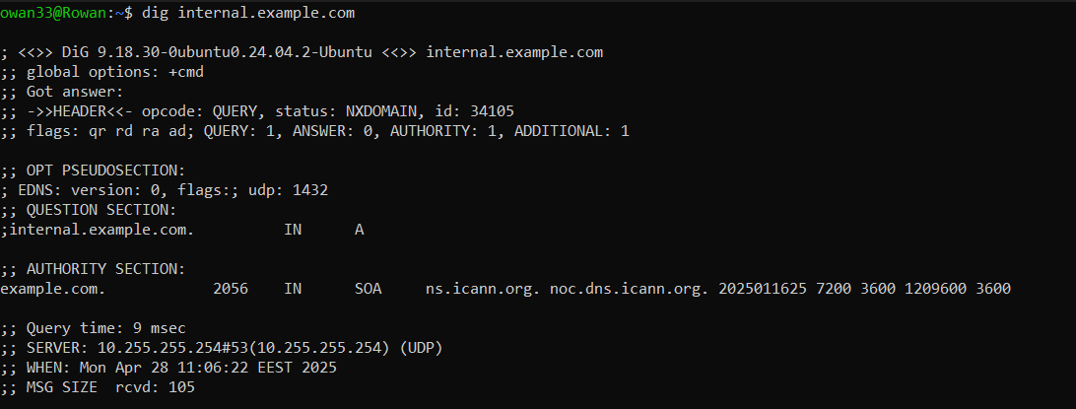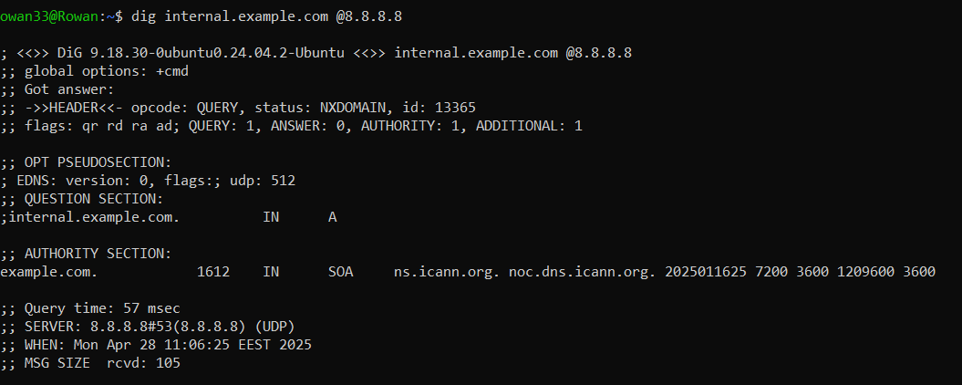

1. Diagnose Service Reachability: Confirm whether the web service (port 80 or 443) is reachable on the resolved IP. Use curl, telnet, netstat, or ss to find if the service is listening and responding.

First, I am trying to resolve or estimate the IP.

After you get the IP address, check if the service is reachable.

For example: 192.168.1.100.

curl -I http://<IP>

curl -I https://<IP>

telnet <IP> 80

telnet <IP> 443

nc -zv <IP> 80

nc -zv <IP> 443

1. Trace the Issue – List All Possible Causes **🧪** Your goal here is to identify and list all potential reasons why [internal.example.com](http://internal.example.com/) might be unreachable, even if the service is up and running. Consider both DNS and network/service layers.

| **Layer** | **Possible Issue** | **How to Confirm** |
| --- | --- | --- |
| DNS | Wrong DNS server configured | cat /etc/resolv.conf |
| DNS | No entry for internal.example.com | dig internal.example.com |
| Network | Firewall blocking DNS responses | Check firewall rules sudo iptables -L |
| Network | Firewall blocking port 80/443 | Try telnet or nc to those ports |
| Web Service | Web server down (Apache/Nginx) | sudo systemctl status apache2 or nginx |
| Routing | Wrong routing, network unreachable | traceroute 192.168.1.100 |
| Hosts file | Wrong/missing /etc/hosts entry | cat /etc/hosts |

4. Propose and Apply Fixes ✅ For each potential issue you identified in Point 3, do the following:

1. Explain how you would confirm it's the actual root cause

2. Show the exact Linux command(s) you would use to fix it.

**A. Wrong DNS Records**

* Check if IP is correct.
* Update the correct A record at your DNS server.

**Use:** dig internal.example.com

**B. Local DNS Misconfigured**

* Check if nameserver points to the correct internal DNS.
* Manually set the correct DNS temporarily:

**Use:** cat /etc/resolv.conf

sudo nano /etc/resolv.conf

sudo systemctl restart systemd-resolved

**C. Firewall Blocking**

Check if any DROP rules block your IPs/ports OR adjust the firewall settings via UFW or firewalld.

**Use:** sudo iptables -A INPUT -p tcp --dport 80 -j ACCEPT

sudo iptables -A INPUT -p tcp --dport 443 -j ACCEPT

**D. Web Service Not Listening**

If nothing is listening on 80/443 ➔ restart the service.

**Use:** sudo ss -tulnp | grep -E '80|443'

**🏆 Bonus:** Configure a local /etc/hosts entry to bypass DNS for testing. Show how to persist DNS server settings using systemd-resolved or NetworkManager.